**INTERNSHIP REPORT**



**SUBMITTED BY**

Ali Raza

2020-ag-6362

**ADVISED BY**

Dr. Nayyar Iqbal

**AN INTERNSHIP REPORT SUBMITTED IN PARTIAL FULFILLMENT OF REQUIREMENT FOR THE DEGREE OF**

*BACHELOR OF SCIENCE*

*IN*

*COMPUTER SCIENCE*

**DEPARTMENT OF COMPUTER SCIENCE**

**FACULTY OF SCIENCES**

**UNIVERSITY OF AGRICULTURE FAISALABAD**

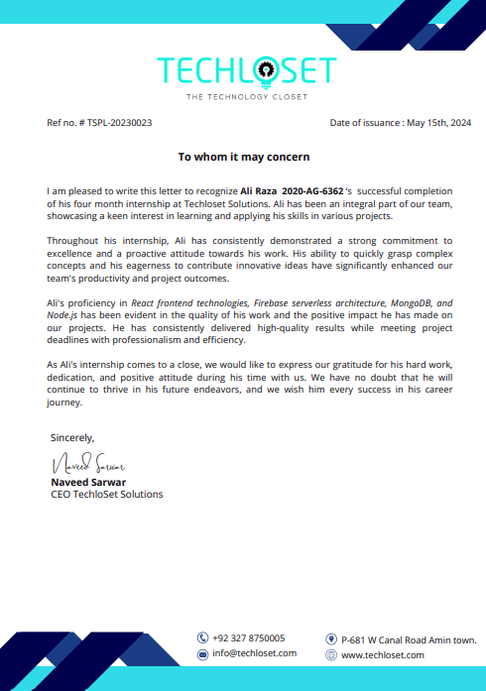

**Table of Contents**

**Acknowledgment** 1

**Purpose of internship:** 2

**Introduction of organization** 3

**Learnt technologies:** 4

**Projects:** 6

**Summary** 12

# **Acknowledgment**

I would like to express my sincere gratitude to all those who have supported me throughout my internship journey. Special thanks to Mr. Naveed Sarwar for his continuous guidance, encouragement, and invaluable insights. I am also grateful to the entire team at Techloset Solution (Pvt.) for their support, collaboration, and the opportunity to learn from their expertise.

I would like to extend special thanks to my supervisor, Dr. Nayyar Iqbal for his guidance in identifying opportunities for professional growth and for his unwavering support throughout this internship. Dr. Nayyar Iqbal’s mentorship and encouragement have played a crucial role in shaping my experience and assisting me in overcoming the various challenges and opportunities encountered during this period. I am truly grateful for his dedication and commitment to my development.

Additionally, Special thanks to my Family for their unwavering support and prayers throughout my degree program. Their encouragement, love, and sacrifices have been a constant source of strength and motivation for me. I am deeply grateful for their guidance, belief in me, and endless support in pursuit of my academic and professional goals.

# **Purpose of internship:**

As a prerequisite for the fulfillment of my Computer Science degree from the University of Agriculture, Faisalabad, I embarked on an enriching internship experience aimed at integrating theoretical knowledge with practical application in a professional setting. The internship served as a pivotal component of my academic journey, providing an invaluable opportunity to gain hands-on experience, hone essential skills, and foster a deeper understanding of industry practices within the field of Computer Science.

The internship requirement set forth by the University of Agriculture, Faisalabad underscored the institution's commitment to producing well-rounded graduates equipped with the requisite skills and competencies to excel in their chosen field. By immersing myself in a real-world work environment, I was able to bridge the gap between classroom learning and industry demands, thereby enhancing my readiness for professional endeavors upon graduation. Moreover, the internship facilitated the application of theoretical concepts to practical scenarios, enabling me to consolidate my learning and develop a nuanced understanding of Computer Science principles in action.

During the internship, I had the privilege of engaging in a diverse array of projects and assignments tailored to my academic background and career aspirations. Under the guidance of experienced mentors and industry professionals, I gained exposure to cutting-edge technologies, best practices, and project management methodologies prevalent in the Computer Science domain. Through active participation in project teams and collaborative endeavors, I honed my problem-solving skills, cultivated effective communication and teamwork abilities, and acquired invaluable insights into the intricacies of software development lifecycle.

# **Introduction of organization**

TechloSet Solutions, established in 2018, is a dynamic Pakistani technology company headquartered in Faisalabad. Their mission is to empower businesses and organizations globally through a comprehensive suite of IT services. With a focus on cutting-edge technologies, they have carved a niche as a leading provider in mobile app development and DevOps solutions.

**Core Strengths**

* **Extensive Expertise:** TechloSet Solutions boasts a team of experienced professionals passionate about staying ahead of the digital curve. They understand the ever-evolving technological landscape and leverage their knowledge to deliver customized solutions that cater to each client's unique needs.
* **Wide Range of Services:** They offer a diverse range of services to cater to various business needs. This includes web application development, harnessing the power of Artificial Intelligence (AI) and blockchain technology. They can craft Internet-of-Things (IoT) solutions, build secure mobile applications, and provide IT consultation services.
* **Commitment to Innovation:** TechloSet Solutions is a company that thrives on innovation. They believe in the transformative potential of technology and are dedicated to using it for positive change. Their team actively explores cutting-edge advancements like machine learning, augmented reality, and blockchain to craft solutions that propel businesses forward.
* **Client-Centric Approach:** TechloSet Solutions prioritizes building strong relationships with their clients. They take the time to understand each client's specific goals and challenges, and then work collaboratively to develop solutions that deliver tangible results. Their dedication to client satisfaction is reflected in their self-reported 100% client satisfaction rate.

**Proven Track Record**

TechloSet Solutions has a portfolio of successful projects that showcase their expertise. They have built visually appealing and user-friendly online platforms like the Fairo app. Their work on the Suvae Client/Admin Dashboard demonstrates their ability to refine user experiences and streamline management tasks. These projects highlight their proficiency in crafting responsive web interfaces that seamlessly adapt to different devices.

**Looking Ahead**

TechloSet Solutions is a company on the rise. With their commitment to innovation, a talented team, and a diverse service portfolio, they are well-positioned to continue empowering businesses through the power of technology. Their focus on building strong client relationships and exceeding expectations ensures their clients can thrive in the ever-changing digital landscape.

# **Learnt technologies:**

I used following tools and technologies for my tasks and projects: -

* Visual Studio Code
* React JS
* Next Js
* React Native
* Redux Tolkit
* Firebase
* Git Hub

**Visual Studio Code:**

Visual Studio Code, also commonly referred to as VS Code, is a source-code editor made by Microsoft for Windows, Linux and macOS. Features include support for debugging, syntax highlighting, intelligent code completion, snippets, code refactoring, and embedded Git. Users can change the theme, keyboard shortcuts, preferences, and install extensions that add additional functionality. VS Code runs on macOS, Linux, and Windows. In the Stack Overflow 2021 Developer Survey, Visual Studio Code was ranked the most popular developer environment tool, with 70% of 82,000 respondents reporting that they use it.

**React JS:**

At the core of modern web development lies React JS, a JavaScript library designed specifically for crafting user interfaces. Developed by Facebook and widely adopted across the industry, React utilizes a component-based architecture. Imagine building your UI with Lego bricks – each component acts as a reusable, self-contained block with its own logic and state. This modular approach keeps your code clean, organized, and incredibly maintainable. But React's magic doesn't stop there. It employs a virtual representation of the actual Document Object Model (DOM) called the Virtual DOM. Whenever changes occur within your application, React intelligently compares the virtual version with the real DOM and updates only the necessary parts. This streamlined process minimizes unnecessary DOM manipulation, resulting in a significant performance boost and a smoother user experience.

**Next JS:**

Next.js takes the power of React a step further by adding features specifically tailored for server-side rendering and static site generation. Think of it as supercharging your React application for optimal performance and discoverability. Server-side rendering translates to lightning-fast page loads, especially for the initial visit, keeping users engaged from the moment they land on your web app. Next.js also optimizes your application for search engines (SEO), ensuring it ranks higher in search results and attracts more organic traffic. But that's not all! Next.js streamlines development by providing built-in functionalities for routing and data fetching, eliminating the need to reinvent the wheel for these common tasks.

**React Native:**

React Native bridges the gap between web development and mobile app creation. This framework allows you to leverage your existing JavaScript and React knowledge to build native mobile applications for both iOS and Android. React Native offers significant advantages like faster development cycles by allowing code reuse between web and mobile applications, and a native feel for the end user on their mobile device. With these three powerful tools in your arsenal, you're equipped to tackle a wide range of web and mobile development projects.

**Redux Tolkit:**

Redux Toolkit acts as a superhero for managing complex application state in React projects. While Redux itself lays the foundation, Redux Toolkit swoops in with a utility belt full of features to simplify the process. First, it eliminates the need for manual store configuration with a concise API. Next, it tackles the challenge of immutable updates by utilizing Immer, allowing you to write intuitive "mutative" code that gets automatically converted into safe, immutable changes. Redux Toolkit also streamlines creating action creators, those functions that dispatch state updates, by providing helper functions. But it doesn't stop there! For better organization, it introduces "slices" – modular units containing reducers, actions, and selectors related to specific parts of your state. Finally, managing asynchronous operations like API calls is a breeze with built-in middleware like Redux Thunk. In essence, Redux Toolkit empowers you to focus on building your application's core functionality by reducing boilerplate code, improving the developer experience, and promoting highly maintainable and well-structured state management.

**Firebase:**

Firebase is a comprehensive mobile and web development platform provided by Google. It offers a wide range of tools and services to help developers build and manage applications efficiently. Firebase provides a backend infrastructure that includes features such as authentication, real-time database, cloud storage, hosting, and more. It simplifies the development process by handling complex tasks like data synchronization, user management, and server-side logic, allowing developers to focus on building the frontend of their applications.

**GitHub:**

GitHub, Inc. is a provider of Internet hosting for software development and version control using Git. It offers the distributed version control and source code management (SCM) functionality of Git, plus its own features. It provides access control and several collaboration features such as bug tracking, feature requests, task management, continuous integration, and wikis for every project. Headquartered in California, it has been a subsidiary of Microsoft since 2018. It is commonly used to host open-source projects. As of November 2021, GitHub reports having over 73 million developers and more than 200 million repositories (including at least 28 million public repositories). It is the largest source code host as of November 202

# **Projects:**

Here are some projects I have done during my internship period:

**Project: Pet Finder Web App**

I built a robust news application using a powerful tech stack including TypeScript for strong typing, React for a dynamic user interface, Tailwind CSS for rapid styling, Redux Toolkit for efficient state management, and Axios for seamless API integration.

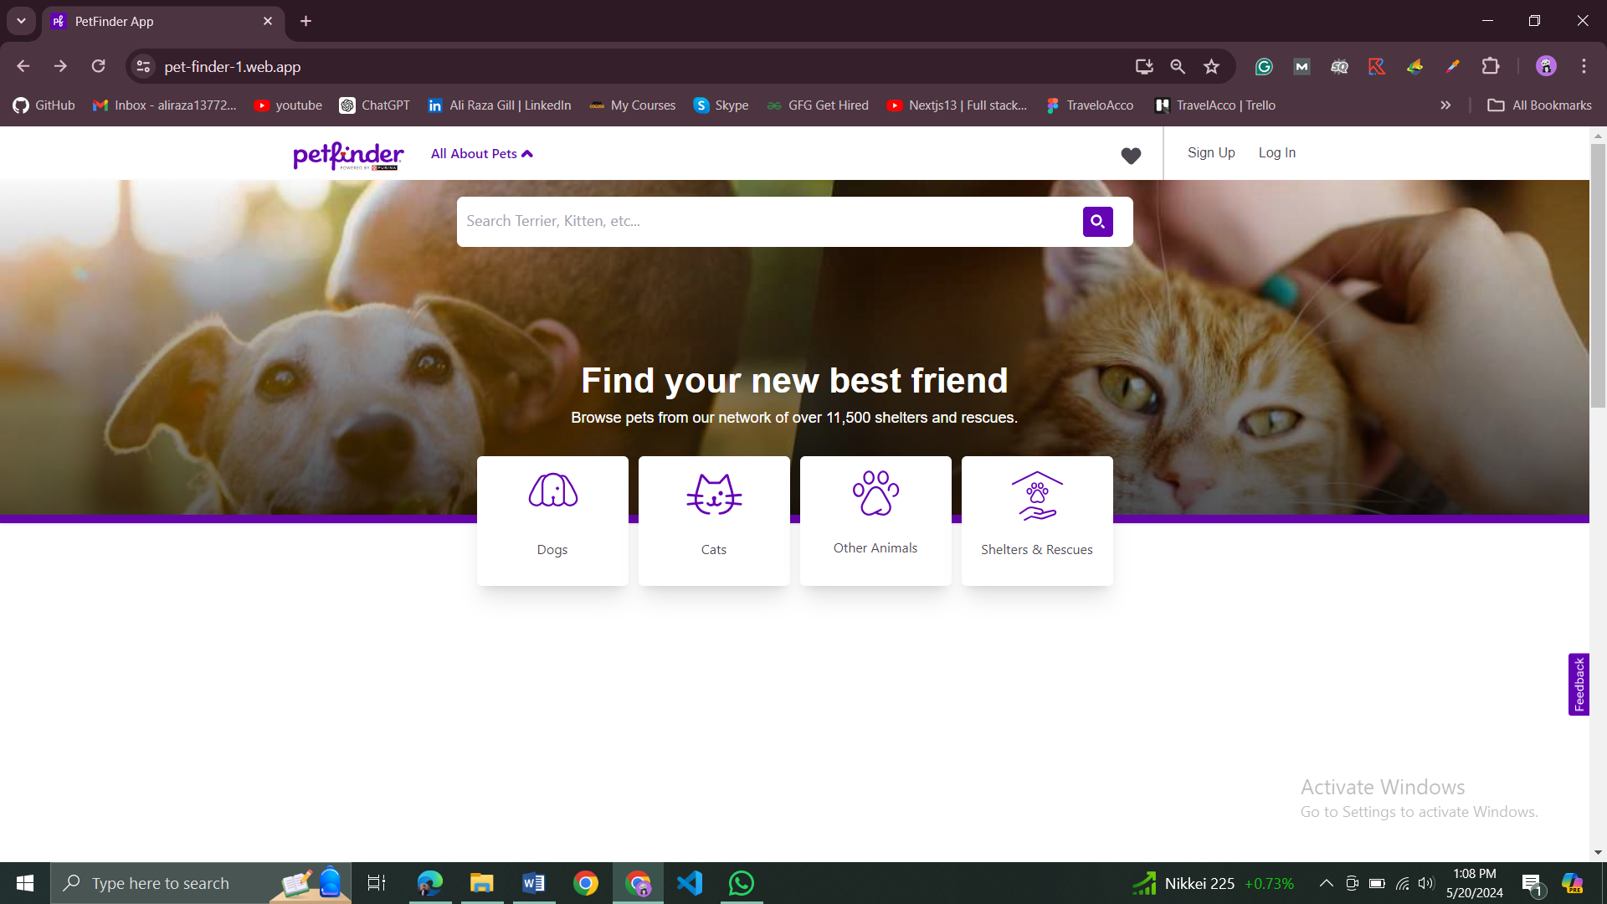

**Key Features:**

* **Seamless API Integration:** Leverages the Pet Finder API to display various news categories and retrieve article details.
* **Enhanced User Experience:**
  + Users can search for specific Pets.
  + Popular content is prominently displayed for quick access.

**Technical Expertise:**

* **Type Script:** Proficient in writing type-safe code for better maintainability and fewer runtime errors.
* **React:** Adept at building user-friendly and interactive interfaces.
* **Tailwind CSS:** Skilled in utilizing Tailwind's utility classes for rapid and responsive design.
* **Redux Toolkit:** Well-versed in managing complex application state effectively.
* **Axios:** Comfortable making HTTP requests to APIs and handling responses.

**Live Demo:**

Check out the live demo of the Pet Finder App is here: <https://pet-finder-1.web.app/>

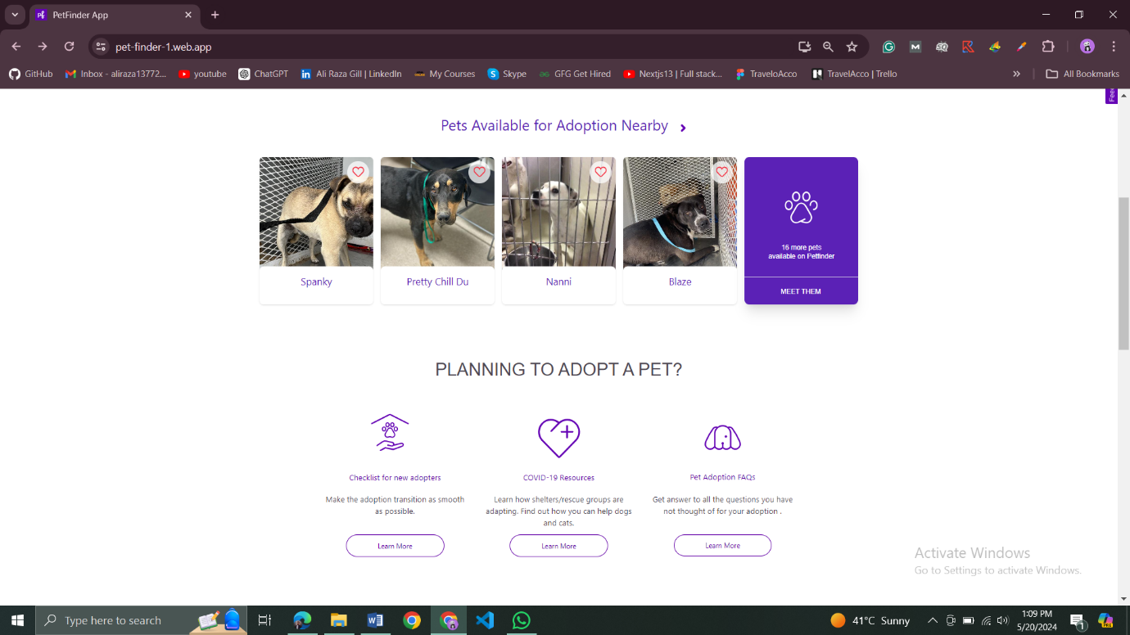

**Pet Finder App:**

My passion for mobile development led me to create a Pet Finder app using React Native. This project allowed me to explore various technologies and hone my skills in building engaging user experiences.

**Tech Stack:**

* **React Native CLI:** Streamlined development for a native mobile app experience.
* **Type Script:** Ensured code type safety for better maintainability and fewer errors.
* **Redux Toolkit:** Managed application state efficiently for a smooth user flow.
* **Firebase Client SDK:** Leveraged Firebase's powerful features for user authentication, data storage, and more.

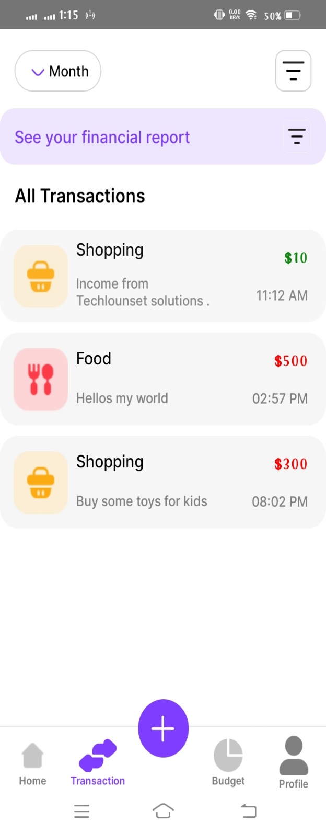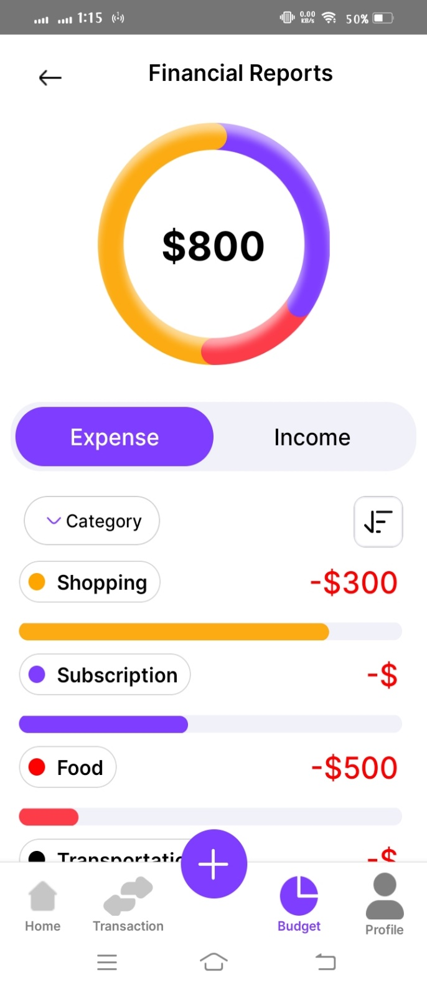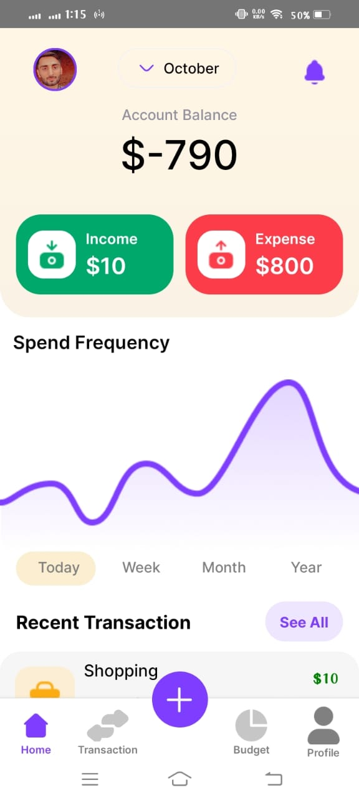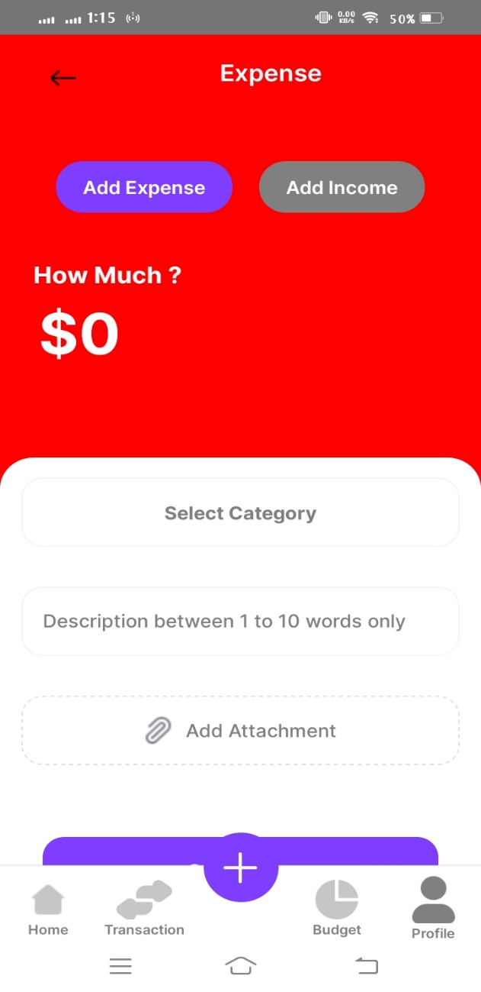

**Engaging Features:**

The app boasts a range of functionalities designed to foster connections and user engagement:

* **Captivating Splash Screen:** A visually appealing welcome screen sets the tone upon launch, grabbing users' attention.
* **Secure Authentication:** Users can securely log in or create new accounts using email/username and password combinations.
* **Password Recovery:** Forgot password functionality ensures a seamless recovery process via email.
* **Dynamic Home Feed:** Explore a constantly updating feed of posts with infinite scrolling for a continuous browsing experience. Clicking on profile pictures within the feed smoothly navigates to the respective user's profile.
* **Effortless Content Creation:** Share your thoughts and experiences through a user-friendly interface built for effortless content creation.
* **Personalized Profiles:** Users can curate their own profiles with usernames, profile pictures, bios, and post history. Editing profile information allows for updates as needed.
* **Exploring Other Profiles:** View profiles of fellow users, gaining insights into their details and post history.
* **Profile Editing:** Enhance your profile by updating information like profile pictures, bios, and other relevant details, complete with proper validation to ensure accuracy.

**Confidential Project Collaboration at TechloSet Solutions**

During my internship at TechloSet Solutions, I had the privilege of collaborating on several confidential projects. These projects involved utilizing a diverse tech stack, including React, Next.js, React Native, and Firebase.

**Understanding Project Needs:**

The first step involved working closely with the TechloSet Solutions team to grasp the project's objectives, target audience, and desired functionalities. We collaboratively defined the specific features to be developed, ensuring alignment with the project goals.

**Strategic Tech Stack Selection:**

Based on the project requirements, the team and I carefully selected the most suitable technologies. Here's how each technology might have been leveraged:

* **React:** For building interactive and reusable UI components. This could have been used for web interfaces or potentially even mobile aspects if a responsive design was necessary.
* **Next.js:** For web applications within the project that required enhanced performance and SEO. This might have been used for public-facing elements or internal dashboards where server-side rendering (SSR) or static site generation (SSG) was beneficial.
* **React Native:** For building native mobile app UI components if the project involved a mobile companion app or a separate mobile application altogether. My existing React knowledge likely proved valuable in building these components efficiently.
* **Firebase:** For providing essential backend functionalities like user authentication, secure data storage, and real-time features (if needed) for both the web and mobile aspects (if applicable).

**Collaborative Development Process:**

* **Codebase Structure:** I collaborated with the team to establish a well-organized codebase structure. This likely involved using tools like Git for version control and maintaining a clear separation of concerns between the front-end (React/React Native) and back-end (Firebase) code.
* **Development and Testing:** I might have been assigned specific features to develop using React or React Native. Collaboration with the team on code reviews and testing ensured functionality and quality throughout the development process.
* **Integration:** Once individual components were developed, I worked with the team to integrate them seamlessly using appropriate libraries or tools.
* **Deployment:** Depending on the project's nature, I might have been involved in the deployment process, ensuring the application was securely hosted.

**Communication and Collaboration Tools:**

* **Regular Meetings:** Regular team meetings were likely held to discuss progress, address challenges, and share updates.
* **Project Management Tools:** Project management tools like Jira or Asana might have been used to track tasks, deadlines, and communication.
* **Code Review Tools:** Tools like GitHub or GitLab might have been used for code reviews and collaboration on the codebase.

By collaborating on these confidential projects, I gained valuable experience working with a professional development team. I honed my skills in utilizing various technologies and the importance of clear communication and collaboration in achieving project goals. This internship experience equipped me to learn and adapt to different technologies, making me a more versatile developer.

# **Summary**

My final semester internship at TechloSet Solutions was an incredible experience that transformed me from a student developer to a more well-rounded professional. Their impressive tech stack, encompassing React JS, Next.js, React Native, Firebase, and Git Hub, wasn't just a collection of tools – it became my development arsenal.

On the front-end, React JS empowered me to craft clean and maintainable code. Next.js, built on top of React, became my secret weapon for optimizing performance and SEO for the web applications I contributed to. Witnessing the impact of these optimizations on user experience was incredibly rewarding.

Beyond web development, React Native became my gateway to the mobile world. By leveraging my existing web development skills with JavaScript and React syntax, I was able to contribute to the creation of native mobile apps. This not only saved time and resources for the team, but also opened my eyes to the possibilities of cross-platform development.

Collaboration was at the heart of this internship. Git Hub, the version control system, became my key to seamless teamwork. It provided transparency into code changes, facilitated efficient troubleshooting, and instilled confidence in my ability to experiment with new features. Witnessing firsthand the importance of clear communication and code reviews within a professional development team was an invaluable lesson.

This internship transcended the technical aspects. It equipped me with the practical skills and collaborative experience essential for a successful career in software development. As I move forward, I carry these lessons and the expertise gained from utilizing TechloSet Solutions' powerful tech stack with immense gratitude.